 | Criteria: What are important qualities of a house?
Alternatives: Types of houses | What is in the house? | How much does it cost? | Where is it located? | What is close by?
Tiny House  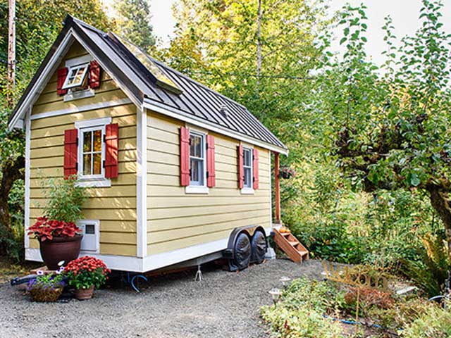 | - 2 bedrooms  - 1 bathroom  - kitchen  - living room  - outdoor space | $50,000  50 thousand dollars  - electricity $75 per month  - additional $50 per month for garbage pick up | The tiny house is located in a wooded area 25 miles from the nearest town. | - Beach – 75 miles away  - School – 30 miles away  - Grocery store – 20 miles away
Yurt  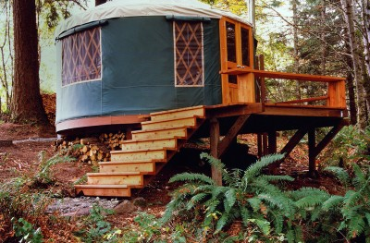 | - 1 bedroom  - outdoor bathroom  - kitchen  - living room with sleeping couch  - outdoor deck | $40,000  40 thousand dollars  - electricity $60 per month  - $25 per month for water | The yurt is located 10 miles from a small city. | - Beach – 125 miles away  - School – 15 miles away  - Grocery store – 5 miles away
Tree House  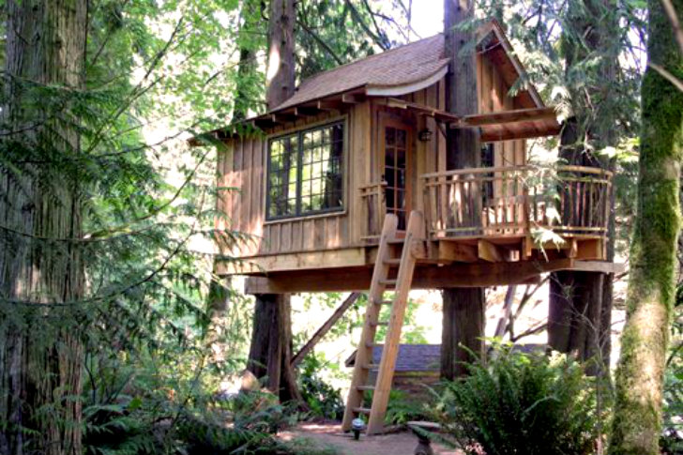 | - 1 bedroom  - 1 bathroom  - kitchen  - living room  - outdoor deck | $35,000  35 thousand dollars  - electricity $25 per month | The tree house is located in a small community of tree houses. | - Beach – 75 miles away  - School – walking distance  - Grocery store – walking distance
House Boat  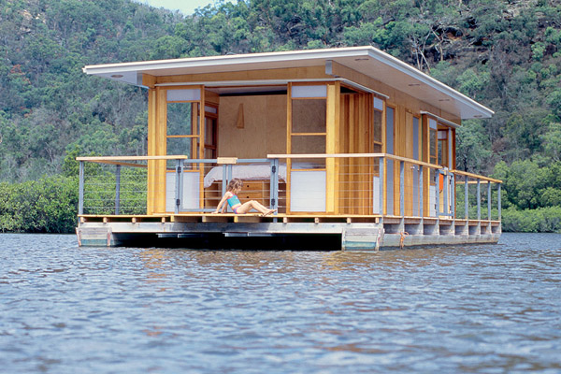 | - 1 bedroom  - 1 bathroom  - kitchen  - living room  - outdoor deck | $75,000  75 thousand dollars  - electricity $70 per month  - $50 per month to tie up to a dock | The houseboat is located on a lake. | - Beach – 30 miles away  - School – 20 miles away  - Grocery store – 15 miles away

