 | Criteria: What are important qualities of a house?
Alternatives: Types of houses | What is in the house? | How much does it cost? | Where is it located? | What is close by?
Tiny House
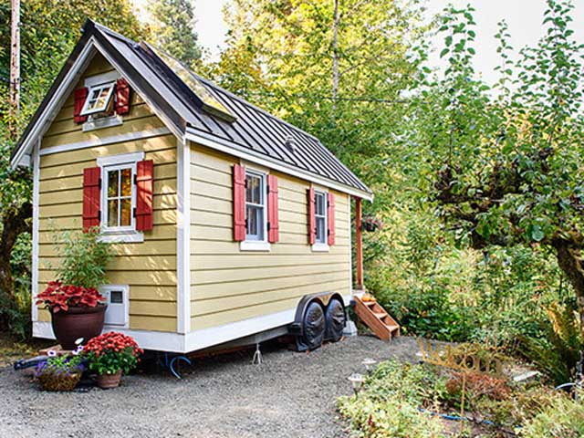
Yurt
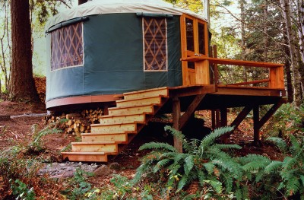
Tree House
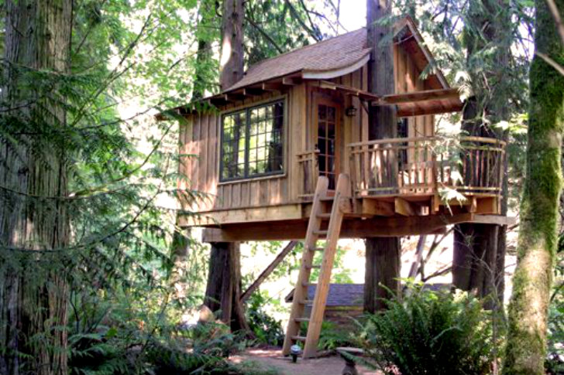
House Boat
